POPPE SITUATION

H1 : Higher level of distrust toward Parliament and political parties will tend to significantly increase the share of votes for populist parties

H2: Younger cohorts (18-34) will probably have lower slopes as the response to the distrust will more likely be astension

H1

I individuated two different dimensions of distrust through factor analysis: institutional distrust and stealth democracy (check bibliography, but tendency to think that political decision should be demanded to different actors from politicians).
A pure logistic model with these 2 performs quite well, specifically for stealth democracy, so our simple HP distrust populist vote is confirmed.
The intensity though is not so strong.
I still have to check through Fratelli d’Italia: it can be quite dangerous as 2022 FDI can be seen as a catch-all party, the main driver isn’t dissatisfaction (as for example was for 5SM in 2018, probably)

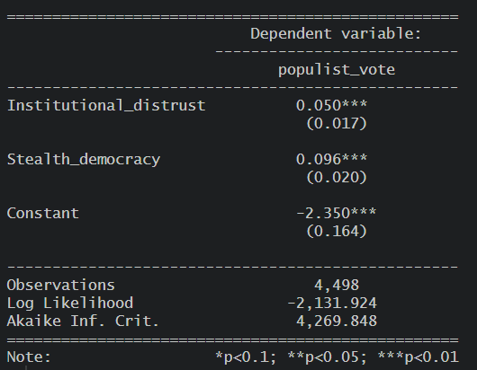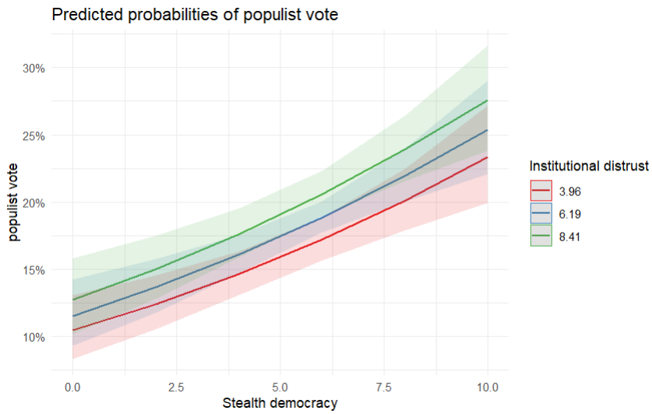

It performs even better with the DBNSM model: I instantiated a model without high levels of distrust (>8) as a gam function showed that there was a inversion in the correlation for high levels of distrust

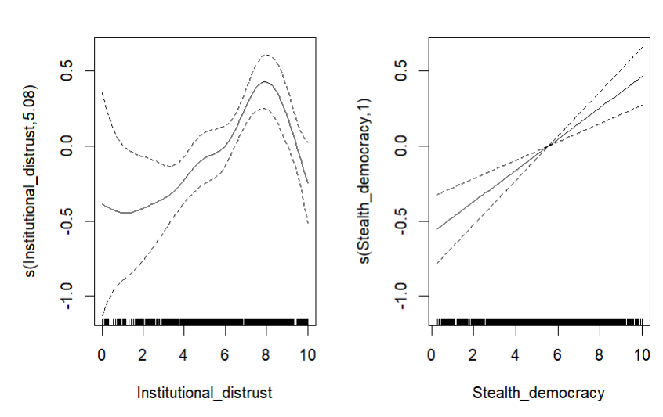
So my H1 is confirmed but is not the hearth of my hypothesis

NB The relationship is way stronger with abstension specially for institutional distrust the effect quadruplicate (0.2), while stealth democracy is quite the same.

H2

Here is where problems start to emerge: there is no significant relationship between age class & populist vote.

From the graphics it seems like there are interesting correlations (also for Abstension – Age Cohort, specially for DBNSM), but the standard deviations are too high to conclude anything.

We can try to implement a multilevel model and try to reduce it but it probably isn’t the resolutions to our problems.

CONTROLS

I controlled by macro region and I discovered hot water: strong correlation with south….

